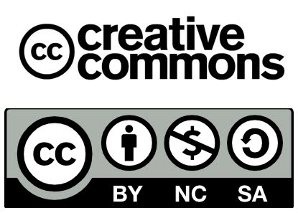

Name:
Class:
Date:

One-minute paper

Without looking at your notes, what was most memorable or stands out in your mind about today’s lesson?

