Activity: Mark your work with a CC license
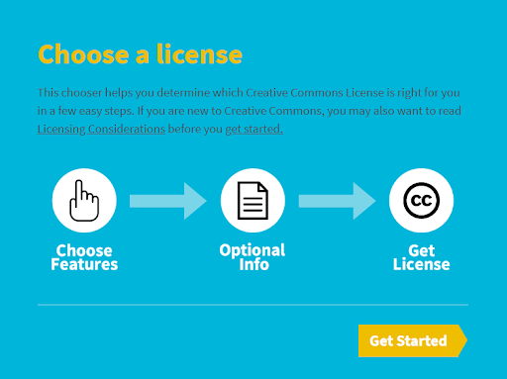
Activity
- Draw a picture with color pencils and paper
- Choose a license using the online tool https://creativecommons.org/choose/?lang=en
- Select License Features: Allow adaptations of your work to be shared? Allow commercial uses of your work?
- Add machine-readable metadata: Title of work, Attribute work to name
- Draw the license icon and copy the text on your paper
- Present your work in the classroom describing the license you chose

Examples
