Activity: Share your work

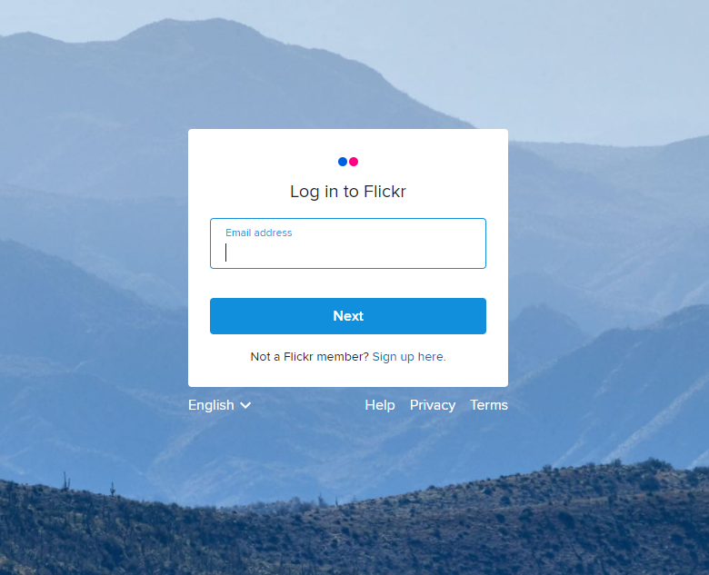
Activity
- Use your mobile phone to take a picture (object, landscape, food etc).
- Share your work on a Creative Commons platform like flickr
  - Create an account in flickr
  - Upload your photo
  - Choose a license for your photo
  - You can also rename your photo, add description and add tags to enhance findability
- Share your photo by posting its link on the padlet. Add the title of the photo and a short description of the license you selected

