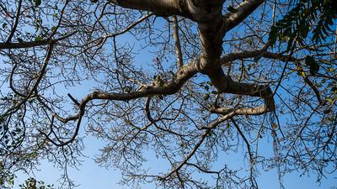
Activity: Finding and Using Creative Commons content
Example
Soaring towards the sky by Kandukuru Nagarjun is licensed under a Creative Commons Attribution 4.0 International License.
Source: https://www.commonsense.org/education/lesson-plans/copyright-and-creative-commons
Group Activity (3-4 students)
- Find images that are marked "CC BY" on flickr or https://search.creativecommons.org/
- Save three images you want to use (anything you want). Make sure to note the:
- author
- title
- license type
- URL
- Create an attribution for each image using the online tool https://creativecommons.org/choose/?lang=en
- Select License Features; add machine-readable metadata; and copy the license icon and text (see the example)
- Using a presentation app (PowerPoint, Google slides) create a slideshow of three images that are attributed to the original author.
- Present your work in the classroom
- You may also find useful information on “How to attribute Creative Commons licensed materials” here and here

Additional information

Creative Commons platforms:

- Creative Commons Search
- Google Image Advanced Search
- Wikimedia Commons
- Flickr Creative Commons

See also:
- How to find Creative Commons materials using Google - Smartcopying
- How to find Creative Commons Material using YouTube - Smartcopying
- How to attribute Creative Commons licensed materials - Smartcopying
- OER - Creative Commons

