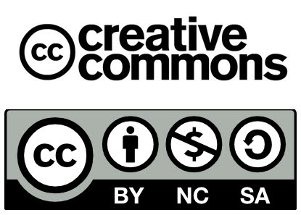

Name:
Class:
Date:

One-minute paper

What idea expressed in the course strongly affected or influenced your personal opinions, viewpoints, or values?

