Discussion
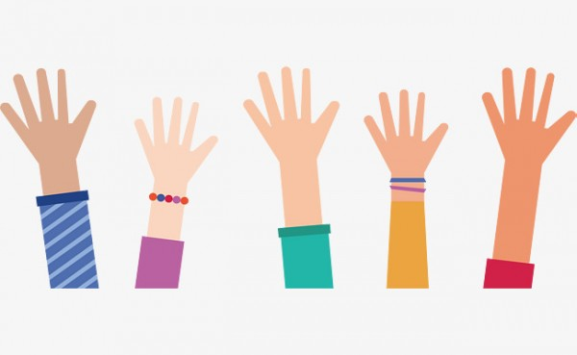
When you publish something it can be hard to control what other people do with it. Sometimes people use our work in ways that don't seem fair to us. I'm going to describe a few situations for you. If you think what happened was fair, raise your hand. If you think it was unfair, keep it down.

- You take an awesome picture and someone puts it on their social media account with your name beside it.
- You write a story and someone else publishes it and says that they wrote it.
- You write a song and someone sings it to her friends.
- You write a song and someone sings it at a concert and makes a lot of money.
- You take a picture and someone else, and someone photoshops it and puts the new version on his web site.
Share your own experiences about creating and sharing content online.

