What are Creative Commons Licenses?
NAME:
DATE:

Poll
Please tick whichever best describes your current competences. There is no right or wrong answer.
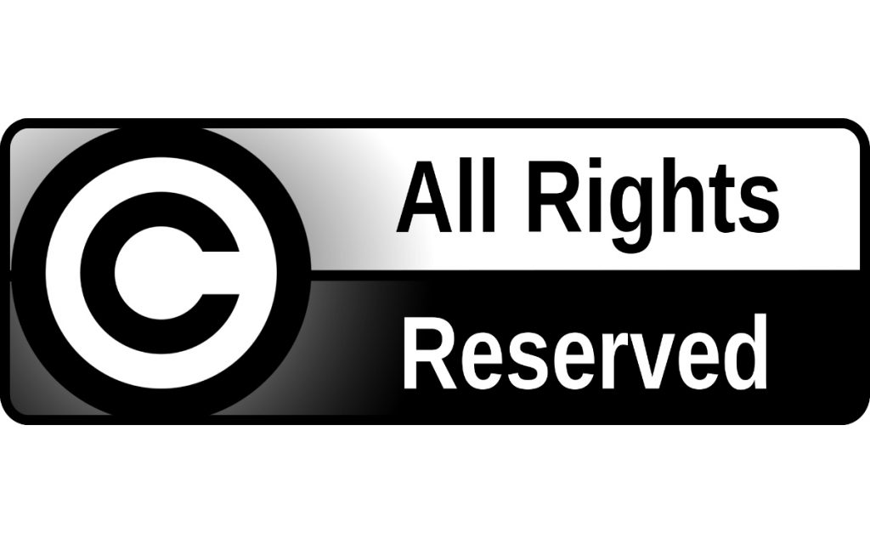
- I am familiar with the term "Copyright"
- Not at all true
- Somewhat true
- True
- Very true
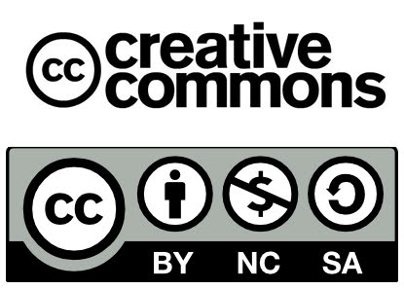
- I am familiar with Creative Commons License
- Not at all true
- Somewhat true
- True
- Very true

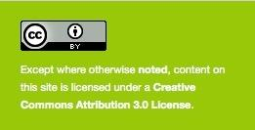
- I am able to mark my work with a CC license
- Not at all true
- Somewhat true
- True
- Very true
- I am able to find Creative Commons content
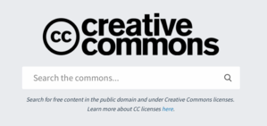
- Not at all true
- Somewhat true
- True
- Very true

Activities
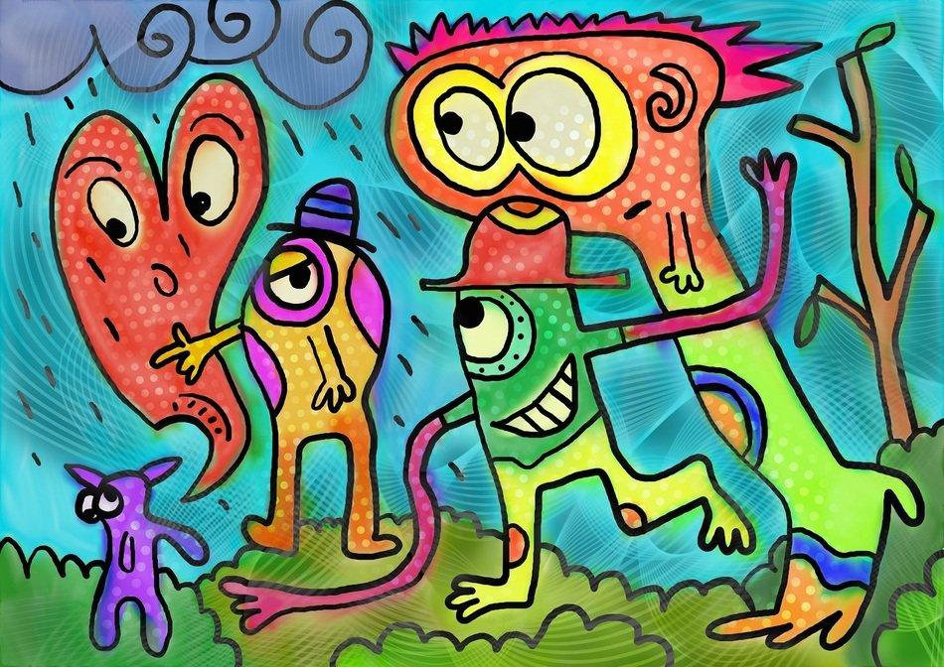
- When you create something like a picture, video, presentation, or essay, you become automatically the copyright holder

- True
- False

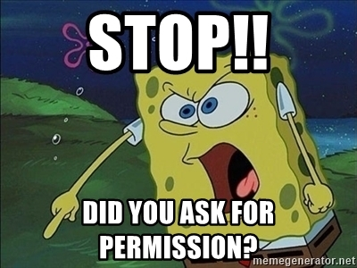
- As a copyright holder, people should ask you for permission to use your work only if it is for commercial use

- True
- False

- Reflect on the problems for the creators and the users when a work is copyrighted

- What does this icon stand for?
- Attribution
- Non Commercial purposes
- No Derivatives
- Share Alike

- What does this icon stand for?
- Attribution
- Non Commercial purposes
- No Derivatives
- Share Alike

- What does this icon stand for?
- Attribution
- Non Commercial purposes
- No Derivatives
- Share Alike

- What does this icon stand for?
- Attribution
- Non Commercial purposes
- No Derivatives
- Share Alike

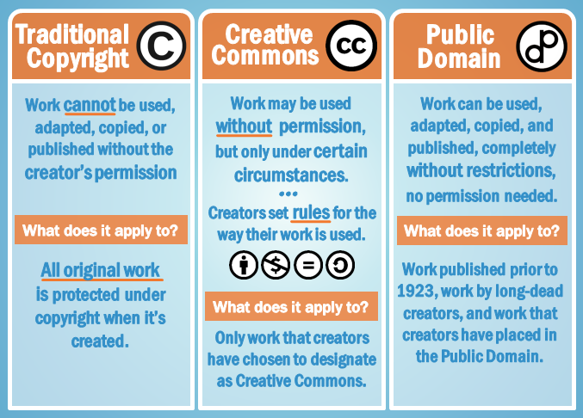
- Review the infographic to get an overview of the differences among
- Traditional Copyright,
- Creative Commons, and
- Public Domain.

- Reflect on your understanding, pointing:
- One difference between Traditional Copyright and Creative Commons License

- One difference between Creative Commons License and Public Domain

